Quiz 04 學號： 姓名：
- The NPN transistor in the circuit of Fig. 1.1 has 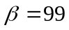. Find the value of 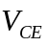. (10 points)

(Ans. 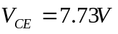)

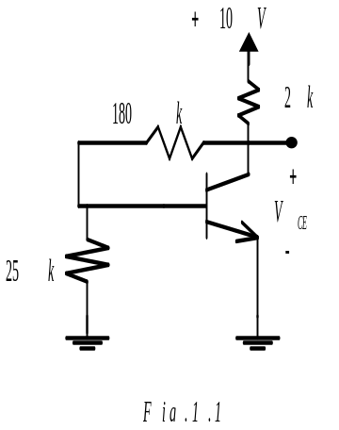
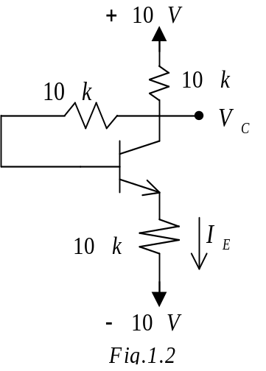
- For the circuit in Fig. 1.2 assume that the transistor has very large . Find  and 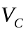 for 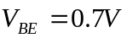. (15 points) (Ans. 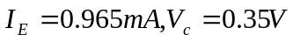)

- A single measurement indicates the emitter voltage of the transistor in the circuit of Fig 1.3 to be 1.0. Under the assumption that , what are 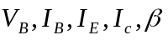 and . (20 points)

(Ans. )

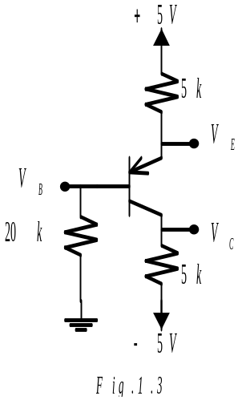
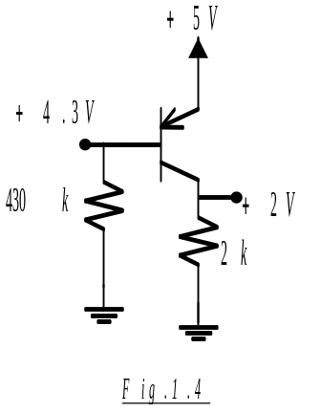
- Measurements on the circuits of Fig.1.4 produce labeled voltages as indicated. Find the value of for the transistor. (15 points) (Ans.  

